LECTURE 1

What is an Operating System?
An Operating System (OS) is a system software that acts as a bridge between the user and computer hardware.
In simple words:
- Hardware cannot be used directly by users
- OS helps users and programs use hardware easily
What an OS does:
- Runs programs
- Allows many programs to run at the same time
- Manages memory
- Controls input/output devices (keyboard, mouse, screen, printer, etc.)
- Makes the computer easy to use
Example:
- Windows, Linux, macOS, Android
Without an OS, a computer is useless.

Kernel
The kernel is the core (heart) of the operating system.
Key points:
- It runs all the time
- It controls everything in the computer
- It directly communicates with hardware
The kernel manages:
- CPU
- Memory
- Devices
- Processes
Important formula:
Operating System = Kernel + Interface + Utilities + Tools
Kernel is always loaded in memory when the system is ON.

Why Kernel is Important?
The kernel is important because without it, the OS cannot work.
Reasons:
- It controls hardware
- It manages system resources
- It handles system calls
- It ensures security and protection
Car Example (from slides 🚗):
- Kernel → Engine
- Operating System → Whole car (engine + body + steering + seats)
➡️ A car without an engine looks complete, but it cannot run
➡️ Same way, an OS without kernel cannot function

Why We Call OS a Virtual Machine?
The OS is called a virtual machine because it creates an illusion for programs.
What illusion?
- Each program feels like:
  - It has its own CPU
  - It has its own memory
  - It owns the system
But in reality:
- Hardware is shared
- OS manages everything behind the scenes
Programs do not directly access hardware
OS acts like a manager and referee

Virtualization
Virtualization means:
Using software (OS) to divide and manage physical resources
What OS virtualizes:
- CPU time
- Memory
- Storage
- Devices
Why virtualization is used:
- Better resource use
- Safe execution of programs
- Multiple programs run smoothly
Example:
- Many apps running at the same time on your laptop
- Each app thinks it has full control
👉 Virtualization = Illusion of ownership

How Multiple Programs Can Run at Once?
This happens because of OS policies and mechanisms.
How it works:
- OS switches CPU between programs very fast
- This switching happens in milliseconds
- Human eye thinks programs run together
Important concept:
- CPU runs one instruction at a time
- OS performs rapid switching
This leads to:
- Multitasking
- Better CPU usage
- Faster system response

Operating System as a Resource Manager
An operating system works mainly as a resource manager.
Its job is to manage all computer resources and share them fairly among programs and users.
The OS manages:
- CPU (decides which program gets the CPU and for how long)
- Memory (decides where programs and data are stored)
- Storage (manages files and disks)
- Input/Output devices (keyboard, mouse, monitor, printer)
The OS makes sure:
- Resources are used efficiently
- No program uses more than it is allowed
- Programs do not interfere with each other

Memory Virtualization
Memory virtualization means the OS gives each program the illusion that it has its own private memory.
In reality:
- Physical memory (RAM) is shared
- OS divides memory among many programs
Benefits:
- Programs are isolated from each other
- One program cannot access another program’s memory
- System becomes more secure and stable
Memory virtualization allows many programs to run safely at the same time.

Model of Physical Memory
Physical memory refers to RAM.
Characteristics of physical memory:
- CPU can access it directly
- It supports read and write operations
- It is volatile (data is lost when power is off)
The OS keeps track of:
- Which part of memory is free
- Which part is used
- Which process owns which memory area
This careful management prevents memory conflicts and crashes.

The Scheme of Things
This shows how different parts of a computer system are organized and connected.
Structure:
- Users interact with applications
- Applications communicate with the operating system
- Operating system communicates with hardware
Main components involved:
- CPU
- Memory
- Disk
- Monitor
- Keyboard
The operating system acts as a middle layer, controlling all interactions between software and hardware.
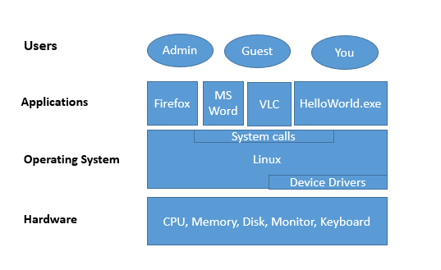
What Happens When You Execute a Program?
When a program is executed (for example, running a program or double-clicking a video):
Steps:
- The program is loaded into memory
- The OS creates a process for it
- The CPU starts executing instructions
- If the program needs hardware access, it requests help from the OS
Programs do not directly access hardware.
They use system calls to request services from the operating system.
This process ensures safety, control, and proper resource usage.
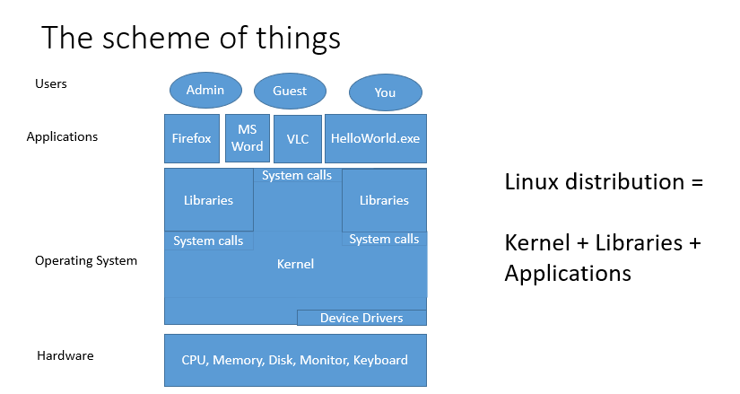

Linux Distribution
A Linux distribution is a complete operating system package built around the Linux kernel.
It consists of:
- Linux kernel
- System libraries
- Utility programs
- Applications
Formula from the lecture:
Linux Distribution = Kernel + Libraries + Applications
Examples of Linux distributions:
- Ubuntu
- Fedora
- Debian
Different distributions may look different but use the same kernel.

What Does an OS Do?
The operating system performs many important functions.
Main responsibilities:
- Manages hardware resources
- Provides services to programs
- Allows communication between running programs
- Ensures protection and security
- Prevents unauthorized access
- Protects the system from faulty programs and external attacks
In simple words, the OS keeps the system organized, secure, and efficient.

Design Goals
Operating systems are designed with specific goals in mind.
Main design goals:
- Convenience: Easy for users to use
- Performance: Fast execution of programs
- Protection: Programs should not harm each other
- Security: Prevent unauthorized access
- Energy efficiency: Reduce power consumption
Good OS design balances all these goals without sacrificing system stability.

Storage Structure
Storage is used to store data and programs in a computer system.
There are two main types of storage:
Main memory:
- Also called RAM
- CPU can access it directly
- Fast but limited in size
- Volatile (data is lost when power is off)
Secondary storage:
- Used as an extension of main memory
- Stores large amounts of data
- Non-volatile (data is not lost when power is off)
- Examples: hard disk, SSD
The operating system manages how data is stored and accessed.

Storage Hierarchy
Storage systems are organized in a hierarchy based on speed, cost, and size.
General characteristics:
- Faster storage is smaller and more expensive
- Slower storage is larger and cheaper
- Higher levels are closer to the CPU
The OS decides:
- What data stays in fast storage
- What data is moved to slower storage
This organization improves overall system performance.

Storage-Device Hierarchy
The storage-device hierarchy shows different storage levels from fastest to slowest.
Typical order:
- Registers
- Cache
- Main memory (RAM)
- Secondary storage (HDD or SSD)
Data moves between levels depending on usage.
Frequently used data is kept closer to the CPU.
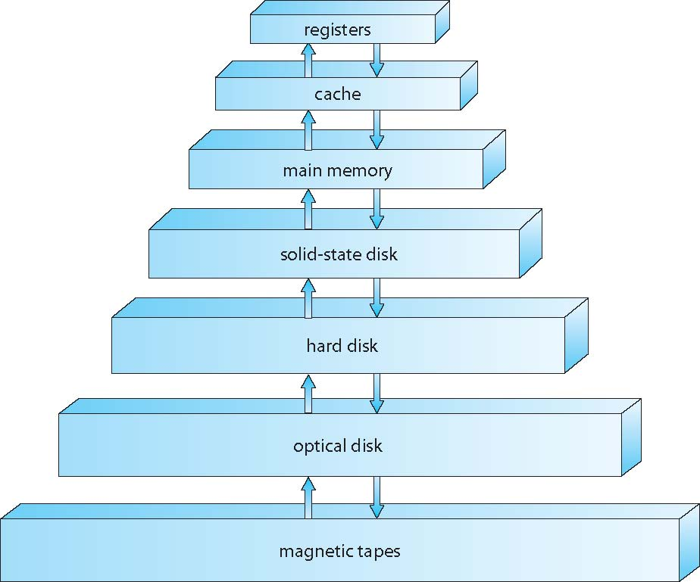

What is Caching?
Caching is a technique where frequently used data is stored in faster memory.
How caching works:
- System checks fast storage (cache) first
- If data is found, it is used immediately
- If not found, data is copied from slower storage to cache
Benefits:
- Faster data access
- Improved system performance
- Reduced load on slower storage devices
Main memory can be considered a cache for secondary storage.

Register
Registers are the smallest and fastest memory units in a computer.
Key points:
- Located inside the CPU
- Not part of main memory
- Store data, instructions, and memory addresses
- Hold information currently used by the CPU
Registers allow the CPU to work very quickly.

Computer-System Architecture
Computer-system architecture describes how the hardware components of a computer system are organized.
Most computer systems include:
- One main processor
- Main memory
- Storage devices
- Input and output devices
In addition to the main processor, systems may also have special-purpose processors that handle specific tasks.
The operating system coordinates all these components and ensures smooth system operation.

Multiprocessor Systems
Multiprocessor systems contain more than one processor in a single computer system.
Characteristics:
- Processors share memory and other resources
- Processors work together to perform tasks
Advantages:
- Increased system throughput
- Better performance
- Improved reliability
- If one processor fails, others can continue working
Multiprocessor systems are also called parallel systems or tightly-coupled systems.

Symmetric Multiprocessing Architecture
In symmetric multiprocessing (SMP):
- All processors are equal
- Each processor performs the same type of tasks
- All processors share main memory
The operating system treats all processors equally and schedules tasks on any available processor.
SMP improves performance and supports parallel execution of programs.

Asymmetric Multiprocessing
Asymmetric multiprocessing is a type of multiprocessor system where each processor is assigned a specific task.
In this system:
- One processor acts as the master processor
- The master processor controls the system
- The master handles scheduling, memory management, and system control
The other processors act as slave processors:
- Slave processors perform only the tasks assigned to them
- They do not make system-level decisions
Because control is centralized in the master processor, this system is simpler to design, but it is less flexible than symmetric multiprocessing.

Dual-Core Design
A dual-core processor contains two cores inside a single processor chip.
Key points:
- Each core can execute instructions independently
- Both cores can run programs at the same time
- Improves multitasking and performance
The operating system schedules tasks across both cores to use them efficiently.

Multi-Chip and Multicore
A multicore processor has two or more cores in one processor.
Important ideas:
- Each core acts like a separate CPU
- Cores can execute instructions simultaneously
- Supports parallel processing
Types:
- Unicore processor: one core
- Multicore processor: two or more cores
Multicore systems increase speed and efficiency without increasing clock speed.

Multiprogramming
Multiprogramming is a technique in which multiple programs are kept in main memory at the same time.
The CPU works on one program at a time, but when a program is waiting for input/output operations, the operating system switches the CPU to another program.
The main goal of multiprogramming is to keep the CPU busy as much as possible.

Why is Multiprogramming Used?
Multiprogramming is used to:
- Maximize CPU utilization
- Improve system throughput
- Reduce CPU idle time
- Allow multiple users or programs to share the system
Without multiprogramming, the CPU would remain idle whenever a program waits for input or output, which wastes system resources.

How Multiprogramming Works
Several programs are loaded into main memory.
Steps:
- One program is given control of the CPU
- If that program needs input/output, it enters a waiting state
- The operating system switches the CPU to another ready program
- This switching continues until all programs finish execution
The switching is fast, so the system appears to run multiple programs at the same time.

Multiprogramming vs Multitasking
Multiprogramming:
- Focuses on keeping the CPU busy
- CPU switches when a program waits for input/output
- Mainly used in batch processing systems
- Improves CPU utilization
Multitasking:
- Focuses on user interaction
- CPU switches between tasks after a fixed time slice
- Used in modern operating systems
- Improves system responsiveness
Both techniques allow multiple programs to run, but their goals and behavior are different.

System Call
A system call is a mechanism that allows a user program to request services from the operating system kernel.
User programs cannot directly access hardware or critical system resources.
Whenever a program needs help from the operating system, it makes a system call.
System calls act as a link between user programs and the kernel.

Why are System Calls Needed?
System calls are needed because:
- User programs are not allowed to access hardware directly
- Direct hardware access can cause system crashes or security problems
- The operating system must control resource usage
System calls provide a safe and controlled way for programs to request services from the operating system.
Why System Calls are Essential?
System calls are essential for the following reasons:
Protection and security:
- Prevents programs from directly accessing hardware
- Protects the system from faulty or malicious programs
Resource management:
- Allows the OS to control CPU, memory, and I/O devices
Abstraction:
- Hides hardware complexity from user programs
System stability:
- Ensures that one program cannot crash the entire system
Without system calls, an operating system cannot function safely.

Common Examples of System Calls
Common system calls include:
- Creating and terminating processes
- Reading from and writing to files
- Opening and closing files
- Allocating and freeing memory
- Input and output operations
- Communication between processes
These system calls allow programs to use system resources properly under OS control.

